It is now possible to create a multimedia-rich video lecture that students may view and hear at a time of their choosing. When you record audio, and potentially webcam-video, to a PowerPoint lecture, it can be published directly to Stream. A stream video is viewable with a direct link or an embed (preferred) in Canvas. Or, you can upload the video to Canvas Studio and install an in-video quiz to encourage attention spans and retention of content.

But, first you must have a Recording tab in PowerPoint, and be signed into your Office 365 account, to have these controls at your disposal. Open your PowerPoint and see if the Recording tab is there. If it isn’t, read on.

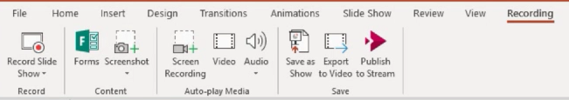

These instructions will enable recording and Stream publishing functions.

First, uninstall Microsoft Office Professional Plus 2016 from your computer.

- Use Settings or search for “Add or Remove Programs” on your Windows 10 computer.
- Select “Microsoft Office Professional Plus 2016” and “Uninstall” 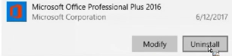
You will be informed that the app and its related info will be uninstalled.
- Click “yes” when you are asked if you are sure.
- Wait for the uninstall-process to finish. This may take a while. Eventually you will be notified that it is done and you can close the window.

If you are unsure of Steps 1-4 above, Tech Support (x3432) will be glad to help you.

Second, install Office 365 from the MyUSF Portal.
- Log into the MyUSF portal with your username and password.
- Select “Tools”- “Office 365”
- Re-enter, as needed, your portal password and click the “Sign-in” button.
- Look for the blue “Install Office” option, select it, and choose “Office 365 apps” 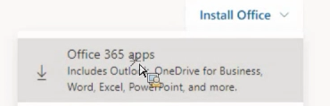
- Save the installation application (.exe) to your computer.
- And double-click on it to launch the installation process. 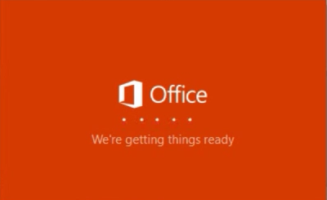
- And wait. This may take a while. You can close the browser windows. The launcher will give you a progress bar, filling orange from right to left. Note that you must be online during this process. It will happen faster over a LAN connection; slower when using wi-fi. 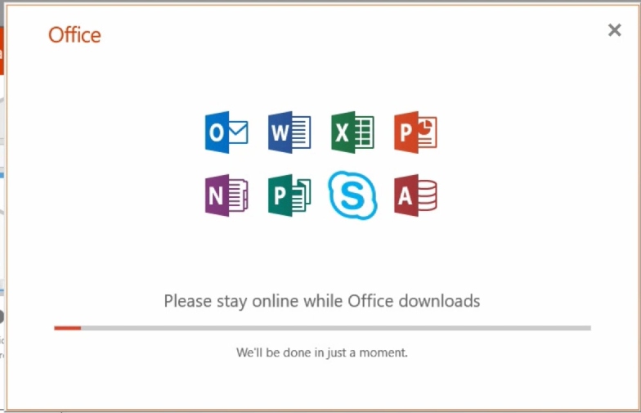
- Upon installation, you will be notified: “You’re all set! Office is installed now.” Close the window.
If you are unsure of Steps 5-12 above, Tech Support (x3432) will be glad to help you.

Third, open PowerPoint and use Options to display the Recording tab.
- When PowerPoint is open, go to File, and then Options (at the bottom).
- When the PowerPoint Options window opens, choose “Customize Ribbon”
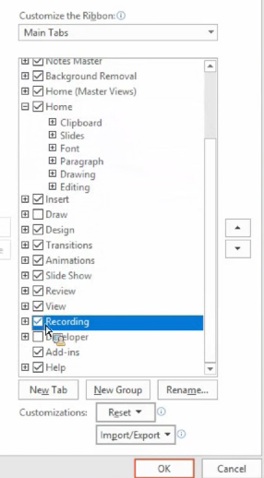
- On the right, under “Customize Ribbon,” scroll down and put a checkmark in “Recording.”
- Click “OK”
- Go to the new Recording tab which appears.
- Locate and click on “Sign in” (if you are not already signed in to Office 365).
- Enter your USF email address.
- Enter your portal password.

Upon completion of steps 13 – 20, you will see the Publish to Stream button appear in the Recording tab.
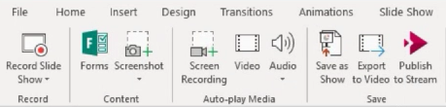

With these capabilities, you will be able to perform the same operations to record and publish a PowerPoint lecture capture that you were able to do in Adobe Presenter and Office Mix. You will be able to:
- Record audio with a suitable microphone (headset-microphone recommended).
- Record video with a webcam and audio if you wish.
- Publish the presentation to Microsoft Stream as a video (which takes a while).
- Publish the PowerPoint file along with the video to the Stream location.
- Go to the Stream site from PowerPoint.

The Academic Technology Team

