The successful submission of a cell phone video to a Canvas assignment depends on the accomplishment of these steps set forth below.

Setting up Your iPhone for “high efficiency” Recording
These steps do not pertain to Android phones.
- Go to your iPhone’s “Settings”
- Swipe down to “Camera” and select it
- Select Formats
- Select High Efficiency, and go back to “Camera”
- Select “Record Video”
- Select the lowest possible resolution: 720p HD at 30 fps. This will give you the smallest video file size resulting in good detail and fastest upload speeds over a good wi-fi connection.

Record Your Video Demonstration or Speech

Submit Your Video to a Canvas Assignment
These steps pertain to both iPhone and Android iPhone users. First, download the free Canvas app to your phone.
- Launch your Canvas app and (first time users) enter your login information as you would for the MUSF portal.
- Select your course (or choose “To do”).
- Select the assignment that requires the video submission.
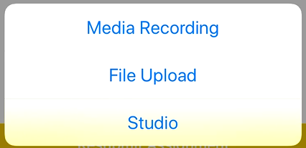
- Select Submit Assignment
- Choose “Studio” (Do not choose “Media Recording”)
- Select “Add”
- Select “Browse Files”
- Select the video you recorded from your cell phone’s library.
- Watch as the video compresses (on an iPhone you will see a thin blue progress bar filling from left to right).

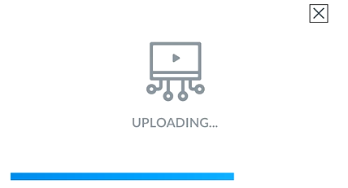
- Watch as the video uploads to Canvas Studio. You will see a blue progress bar filling from left to right.
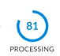
- After the video uploads, watch as the video undergoes “processing.” You will see a small wheel filling with a clockwise moving blue circle and a percentage increasing.
- When processing is finished, you will see a green check mark.
- Select the video (tap it)
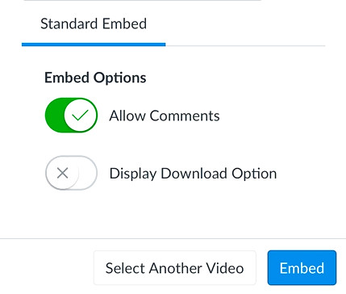
- Select the “Embed” command with the option chosen by default to “Allow Comments”

You will see a confirmation that the video was successfully submitted.
Watch for your instructor’s evaluation and comments on the video under Recent Feedback in Canvas.

