Faculty and students may benefit from the inexpensive method of converting audio to closed captions and then to text transcripts that is available through use of Canvas Studio.  Check that:  it's free.

Doing research sometimes means recording lengthy audio interviews or focus group sessions, and then generating a written transcription that can be used to capture quotes or, more meticulously, apply grounded theory methods, for example, in formal research studies.  In olden times, one used audio tape, and waited, and waited, and waited for a professional service to type up a transcription at cost (and a pretty penny indeed it was).  In these digital times, a tapeless audio recording is automatically transcribed by a seemingly intelligent software, which then spits out a text file-- in minutes.

The challenge is to find the resources to do it.  I am going to report these to you, now.

First, you must acquire a good speech-quality audio recorder.  My device of choice is an Olympus recorder that has a USB output to transfer the audio file (an "mp3") into the computer.

|  |  |
| --- | --- |
| cid:f55d789e-43cb-45fa-9c18-6741b956bf3c | Olympus WS-853 (probably has been updated).  You will pay a modest price but it's one time only.  For me, the good quality audio is worth it.  In fact, I used audio from this very device to support the audio you heard in the "From Slavery to Glory" documentary about Fr. Augustus Tolton that aired on WTTW-TV. |

The mp3 audio file will have an alphanumeric filename.  For ease in recognition later, I would rename it to something familiar, like "subject_interview_date_time.mp3."

In Canvas, you open Canvas Studio, and upload the mp3 audio file by choosing "Add" and then the option to upload media files.

The table below illustrates the steps.  Read these from left to right on the top row, and from left to right on the second row.

|  |  |  |
| --- | --- | --- |
|  |  |  |
| cid:02518c9a-2166-498a-aa4f-dc6c2ba1837f After processing, the media file is displayed as a waveform, and you can double-click on it to open it in full view. | cid:ae600393-b630-49b7-8d37-d8ac491bd951 You then select "Captions" and choose the language that is spoken, and click "Request." | cid:1278276a-2887-4376-ad54-440cabe100ef  It will take a few minutes for the automatic captioning software to generate the captions. |
|  |  |  |
| cid:3993f658-e396-4eac-858c-2b18311c063dYou can walk away and receive an email notification that the captions are ready to be reviewed and published.  Publish the final result (if you wish to edit first, you can.) | cid:820bbc4b-77e8-4b9a-8318-e618c715e725Next, you can download the captions file. | The downloaded file will have the dot extension ".srt" which will open with a text reader (use a right-mouse click on the file to browse the options for reading the file). |

Again, I would change the name of the downloaded .srt file to something recognizable later on, like "subject_interview_data_time.srt".

What will you see when you read the .srt transcript?  You will see a line-by-line transcript, with each line preceded by a timestamp, very much like the view shown below.  That timestamp marks the location in the audio file where the audio is heard.  That can be handy when reviewing the audio itself to see how well it matches the transcript (it should have more than 85% accuracy if the audio is clearly recorded).

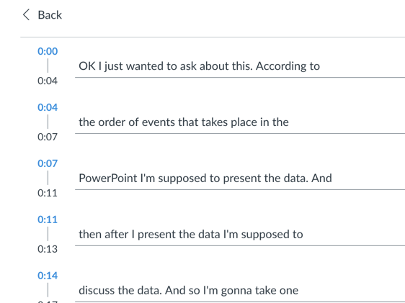

However, this can be difficult if you want to copy and paste the text into Word.  There is a solution for that and it is free, online.

Go to <https://subtitletools.com/>, where you will find details on how to upload your .srt file and have it transcribed to straight text.  I would choose the option to eliminate blank lines.  Follow these instructions and you will be prompted to download the text file.  Just be careful to download only the text file.  The site has multiple "download" invitations that I would ignore completely.  (You can Google alternate transcription sites.  I used "rev.com" to pay for professional audio transcription to support my doctoral dissertation; 100% accuracy which I deemed worth the dollar-per-minute expense).

The result will be a text file not unlike the one shown (from an Illinois village trustees meeting) below that you can copy and paste and use heartily in your research or teaching activities!

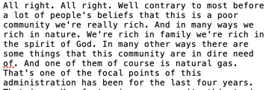

I welcome your questions and applause.

Glen Gummess,

Educational Technologist